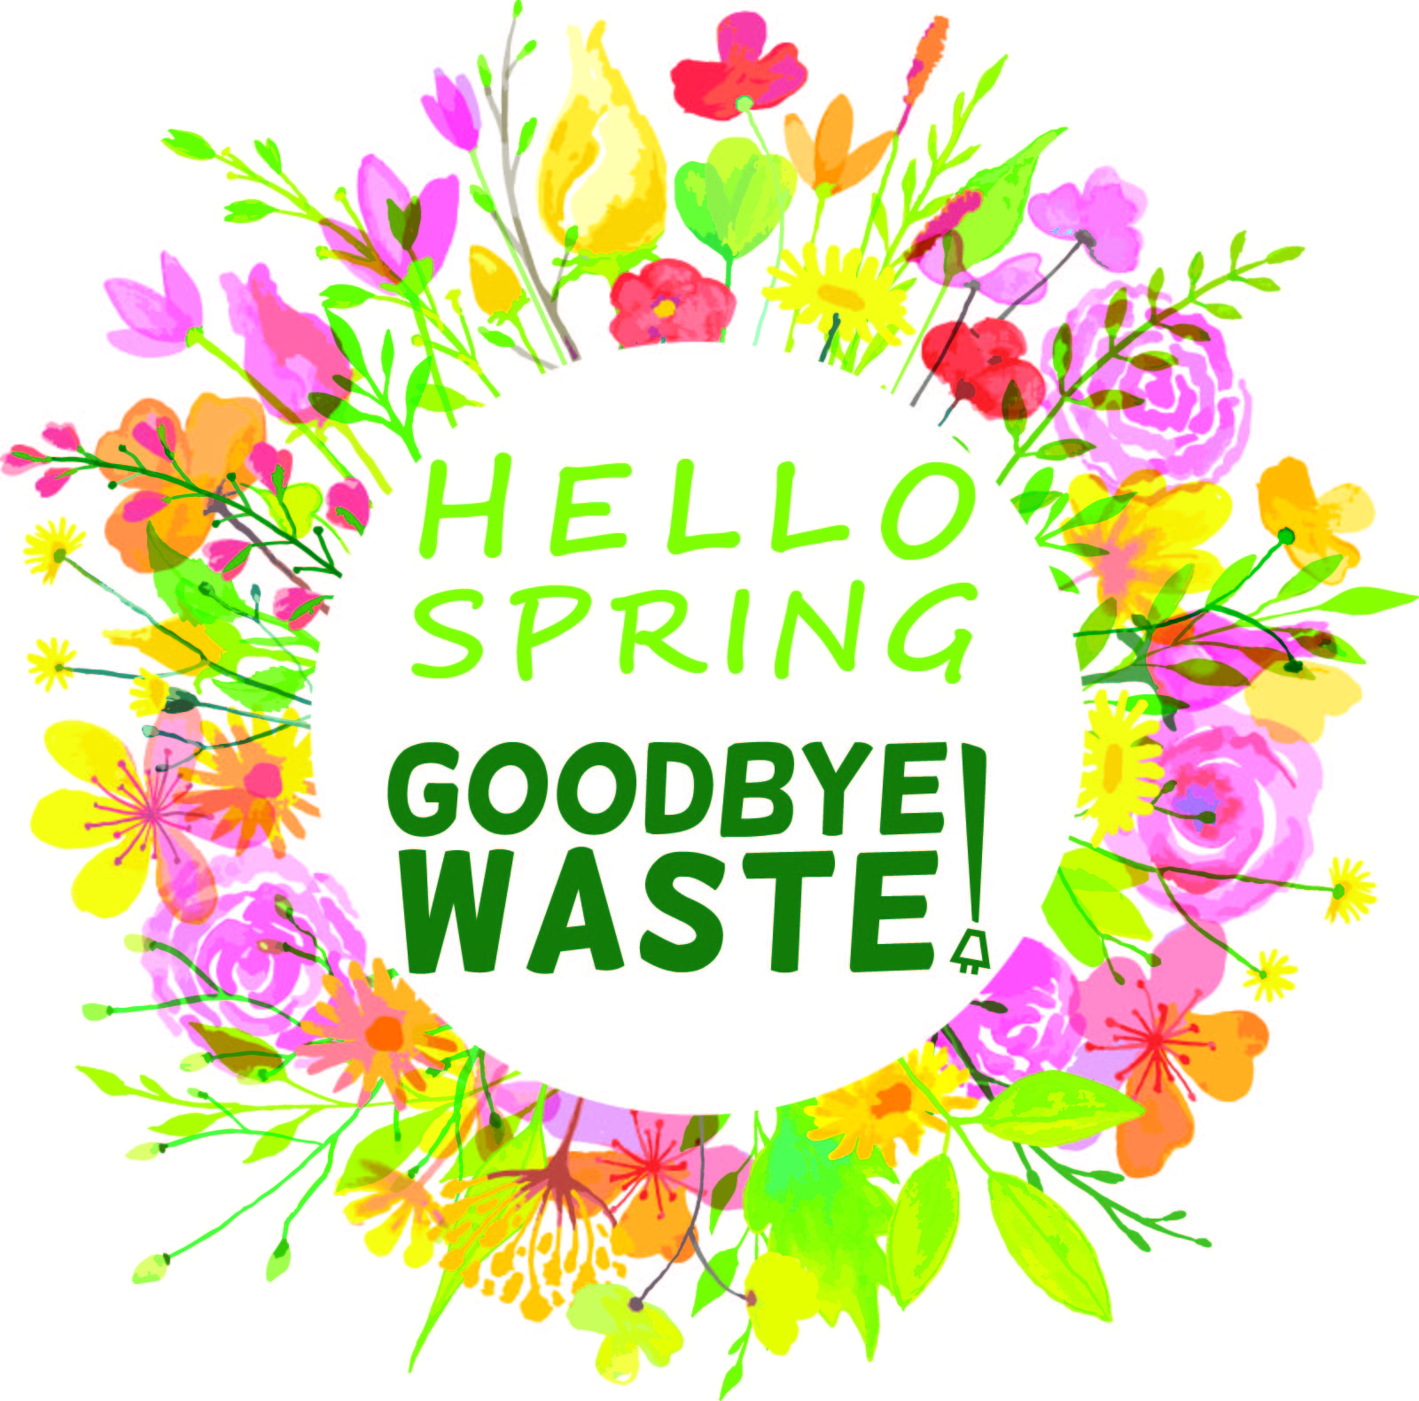
Spring Shutdown Checklist
Use this checklist to help with your shutdown on the last day of class.
Device | What Can I Do? |  |  | Special Notes | Action
 | Sleep Mode | Turn Off | Unplug
Classrooms
Computer in classroom | Y | Y | N
Computer monitors | - | Y | N
Laptop cart computers | Y | N | N
Laptop carts* | - | Y | Y | Computers off before carts
Laptop cart printers | Y | Y | N
iPads | Y | Y | N
iPad carts* | - | Y | Y | iPads off before carts
Smart Board | Y | Y | N
Projector (desktop) | Y | Y | Y
Projector (ceiling mount) | Y | Y | N
Television | - | Y | Y
Electric pencil sharpener | - | Y | Y
Fish tank / Terrarium | - | N | N | By owner only
Workstations
Task lights | - | Y | N
Small kitchen appliances | - | Y | Y | With light, clock or switch
Personal space heaters | - | Y | Y | Always unplug for safety
Desktop Computer | Y | Y | N | By owner only
Computer Monitor | - | Y | Y
Desktop printer | Y | Y | Y
Cellphone charger | - | Y | Y
Powerbars | - | Y | N
Office
Printer/copier/scanner | Y | N | N
Large RICOH copiers | Y | Y | N
PA System | Y | N | N
Staff Room
Small kitchen appliances | - | Y | Y | With light, clock or switch
Commercial coffee urn | - | Y | Y | Ensure water emptied
Special
Computer lab computers | Y | Y | N | Master power switch
Computer lab monitors | Y | Y | N
Listening Centres | - | Y | Y
Hallway televisions | Y | Y | N
Cafeteria | - | Y | Y | Cafeteria staff only
Shop | - | Y | N | Shop teacher only
* upon return to school, must be plugged in to re-charge.
Please remember to turn off the lights and close the windows, blinds, and shutters too!

